Digital Test Hammer
（V1.41）

User Manual

Thank you for choosing our products!
In order to make you have a better understanding and correct use of this product, please read this manual carefully before using it.

Preface
Dear users,
It is a great honor for us to be our customers. To help you use the product expertly and understand the performance of rebar detector including on-site measuring method and environment analysis, technical parameters and data processing etc., please be sure to read the manual carefully and other relevant information about the product.
The international advanced IC technology and the new-type LCD display have been adopted in Digital Test Hammer. Owning to its advanced design, excellent fabrication, high reliability as well as its rigorous technical evaluation in the research and fabrication process, the performance indexes have reached and even exceeded the international advanced level. To help you solve the technical problems conveniently you may encounter in use, we have made a detailed description and explanation in this manual. If you have any problems with the product, please refer to the relevant parts of this manual, or contact our company directly.
On the basis of the relevant technology, we strive to make the manual comprehensive and easy to understand. With the continuous accumulation of on-site detection experience, we upgrade and improve the product constantly. If there are any editing errors and improper rendering in the manual, we hope to obtain your correction sincerely.
Please check carefully whether the information of instrument is complete and the instrument ＆ accessories are in line with the packing list. If there are any problems, please contact our company. After purchasing it, please carefully read the relevant information of the instrument to ensure the right and service you have.
If you have any incomprehension in the manual, welcome you telephone us or write to us for further consultations and negotiations so that we can offer good service.

Contents
1 Introduction 5
1.1 Introduction: 5
1.2 Features： 5
1.3 Main Specification: 7
1.4 Attention 8
1.5 Service and maintenance 9
1.6 Liability 12
2 Digital Test Hammer Details 14
2.1 Digital mode: As Fig.2.1 a b c d e. 14
3 Operation Process 17
3.1 Data collection process. 17
3.1.1 Main menu. 17
3.1.2 Testing menu 18
3.1.3 Choose menu or setup 19
3.2 Main Function Introduction. 19
3.2.1 Schmidt Hammer (Rebound Value Testing) 19
3.2.2 Measurement Setup 23
3.2.3 View Data 26
3.2.4 Management Data 27
3.2.5 Delete 29
3.2.6 Calibrate 30
3.2.7 System Setup 32
3.2.8 Shut down 34
4 Fast Testing Operation 35
4.1 Prepare before testing 35
4.1.1 Field Prepare 35
4.1.2 Turn on 35
4.2 Rebound testing & Parameter Setup 36
4.2.1 Rebound Testing 36
4.2.2 Parameter setup. 37
4.3 Data Processing. 37
Producer Certificate 38
Package List 39
Product Warranty Card 40

1 Introduction

1.1 Introduction:
Our company Digital Test Hammer automatically Record, Save, Calculate and Processing data.

1.2 Features：
1. Automatically display and record the rebound value, and calculate the converted intensity value of each measurement area and the estimated strength of the component according to the relevant inspection specifications.
2. 2.0-inch color LCD screen (220 × 176 pixels), clearly visible inspection data in any situation.
3. Color digital module and mechanical rebound meter can be disassembled at will.
4. Standard battery module, free to dismantle, replace anytime, anywhere, fully realize double power and double charge, unlimited field test.
5. Silicone button design, flexible use; ergonomic design, comfortable and warm heart; streamlined elegant design, smiling look and feel.
6. Support Simplified Chinese and English multi-language display.
7. Multiple data transmission modes, simple, accurate and convenient operation.
8. The carbonization value in the measurement area can be entered 3 times and the average value is automatically calculated.
9. Selective transmission, printing, export, and deletion of test components, easy operation;
10. Built-in steel anvil calibration function to record calibration information.
11. Support personal customization (contact supplier before purchasing) instrument standard specification and program update function.
12. Optional Bluetooth printer for on-site data printing, efficient and intelligent, easy to record raw data on site (limited to different models).
13. Equipped with business diagonal cross leather bag, easy to carry, easy to operate, easy to use, and wear-resistant
14. Noisy scene, you can use universal headphones (earphones are provided), plug in the earphone dedicated port to avoid external interference
15. Any on-site operator of this product can freely disassemble and replace the rebound meter without training (see operation video for details)

1.3 Main Specification:
Digital Parts
Display | 2.0inch （220×176 pixels ）
Language | Chinese、English
Output Mode | Digital display, Voice report, Bluetooth printing, WIFI upload
Storage Capacity | 2000 pcs, 640 thousand data
Turn off | Automatic turn off without operation
Power supply | 3.7V Lithium battery, 1050 mA.  (removable at will), support dual power dual charge
Operation method | Silicone buttons
Communication Interface | USB interface, Bluetooth interface, Wifi interface
Port | USB (update type Bluetooth and WIFI. )
data processing | Automatic data analysis and test report export
Collection Mode | Automatic display and record data
Size(mm） | 150×62×39
Weight（kg） | 0.1kg（include battery）
Schmidt Hammer
Standard impact energy | 2.207J
Rigidity of tension spring | 7.85N/m
error range for digital displayer | ≤±1（the difference between displayer and scale）
Average rebound hammer on steel anvil Rm | 80±2
Size（mm） | Ø60×280
Weight（kg） | 0.1kg

1.4 Attention
For your better use of this product, please read the use manual carefully before use, fully understand the use of detectors and software and precautions.
1.Working environment requirements
    - he environment temperature: -10 to +42 ℃
    - The relative humidity: <90%RH
    - The electromagnetic interference: no strong alternating electromagnetic field
    - Do not exposure to or use at direct sunlight for long time, otherwise may cause the detector can not work properly.
    - Anti - Corrosion: in damp, dust, corrosive gas environment, should take the necessary protective measures.
2. Storage environment requirements
    - The environment temperature: -20 to +50 ℃
    - The relative humidity: <90%RH
    - Products shall be placed in the detector box, placed at room temperature for ventilation, cool and dry; if not used for a long time, should regularly check and power it on.
- Avoid entering water.
- Antimagnetic: avoid the use of strong magnetic environment, such as large electromagnet, transformers and other nearby.
5．Shockproof: in use and transportation process, should prevent violent vibration and impact.

1.5 Service and maintenance
1.Operation
When press the buttons, should not be forced too much, should not be stained with too much oily or muddy hand operating detector keyboard, so as not to affect the keyboard service life.
2. Power supply
The detector uses built-in rechargeable lithium battery power supply. It can standby for not less than 2-4 hours. Please note that when the power indicator shows insufficient, you should shut down the detector as soon as possible and charge the detector timely, otherwise may cause a sudden power failure and lost test data or damaged equipment.
The battery standard is 3.7V and the capacity is 1050mAh (3.885Wh). Because the battery is easy to remove and remove, it is forbidden to short-circuit the battery or approach the high temperature heat source
- Attention：
 Shows the power status； Indicates need recharging；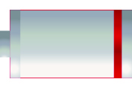 Indicate power is completely discharged.
3. Charging
This detector is equipped with lithium battery, it is recommended to charge in the shutdown state. Support Micro USB standard charging port, please use the charger, power supply socket socket terminal to AC220 + 10% V and the other end of the Micro USB is plugged in USB interface equipment or directly use of USD cable can be plugged into the computer. When charging, the charging indicator light is red, indicates charging the detector built-in lithium battery; when the lights changed to green, indicates the battery is full, you should promptly unplug the charger or USB line, so as to avoid excessive battery charging of battery life. During the charging process, the detector battery and charger will produce a certain amount of heat, which is a normal phenomenon, so it is recommended to put the detector in good ventilation, easy to dissipate heat.
The second method supports direct charging of the battery using a battery holder charger (available separately from the supplier)
- Attention：
In order to ensure adequate power completely charging, please keep the charging for about 4 hours, Do not charge at the environment exceeding 50 ℃. The charging current is large, suggest you use the original charger USD cable, otherwise may cause damage to the detector.
4. Storage and Clean
When the detector is not in use, please put it in the detector box and keep it in a ventilated, cool and dry (relative humidity less than 90%) room temperature environment. If not used for a long time, the rechargeable battery will naturally discharge, resulting in reduced electricity. Therefore, please charge before use, and regularly power on to check the detector and generally charge every one month.
Every time after using this detector, the detector should be properly cleaned, to prevent water, oil, mud, dust into the connector, thereby affecting the test performance or poor measurement and other phenomena.
Attention：
Don't put detectors and accessories in water or scrub with wet cloth!
Do not use organic solvents or acid-base liquids to scrub detectors and accessories!

5. Failures and solutions
The detector can not boot: check whether the battery is sufficient or direct access to the power adapter after the start; connect the power adapter, open the detector power soft switch. If the above methods are invalid, connect the power adapter and recharge the battery half an hour later.
Detector automatic shutdown: detector has the ability to detect the battery, when the battery is too low, the detector will automatically shut down; Start charging for a period of time of the battery, or direct access to the power adapter, and then reboot.
Attention：
Our company provides one year warranty and lifelong maintenance service for this detector; please contact our company or dealers for detector maintenance. self repair is not recommended.

1.6 Liability
The detector is a precision testing detector, if the user has the following behavior or man-made damage, the company does not bear the responsibility:
1. The condition of abnormal operating detectors.
2. Open the machine and disassemble any parts without permission.
3. Violation of the above working environment requirements or storage environment requirements.
4. Serious damage caused by human or accidental collision.

2 Digital Test Hammer Details
It includes Digital Mode, Mechanical Rebound, Charger, Mic USB and tools.

2.1 Digital mode: As Fig.2.1 a b c d e.
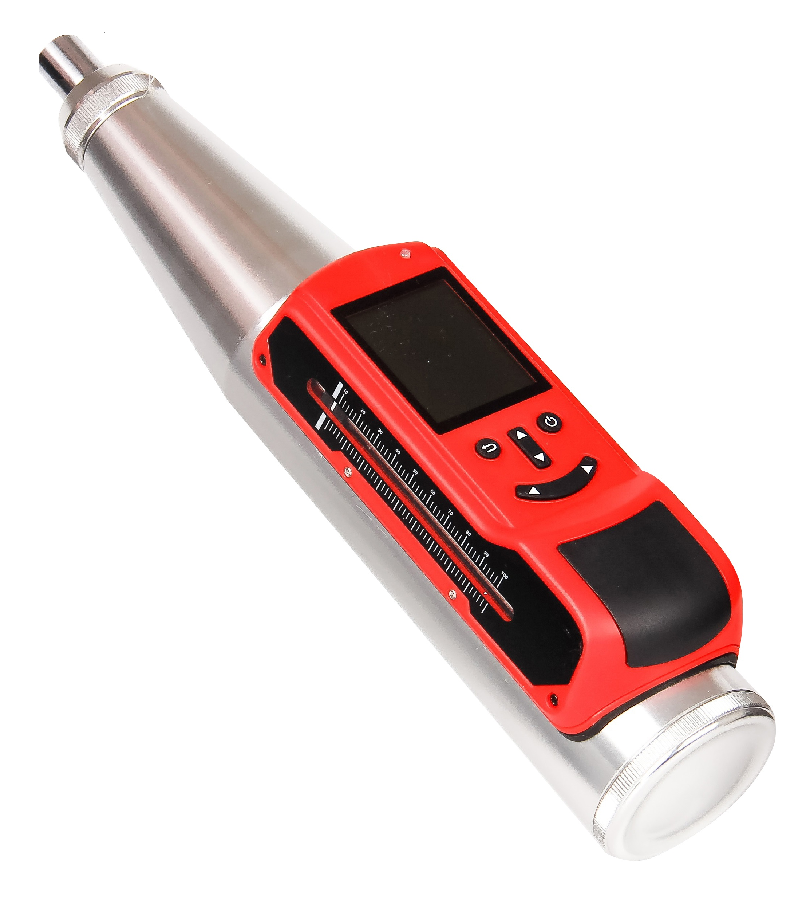
a) Whole System
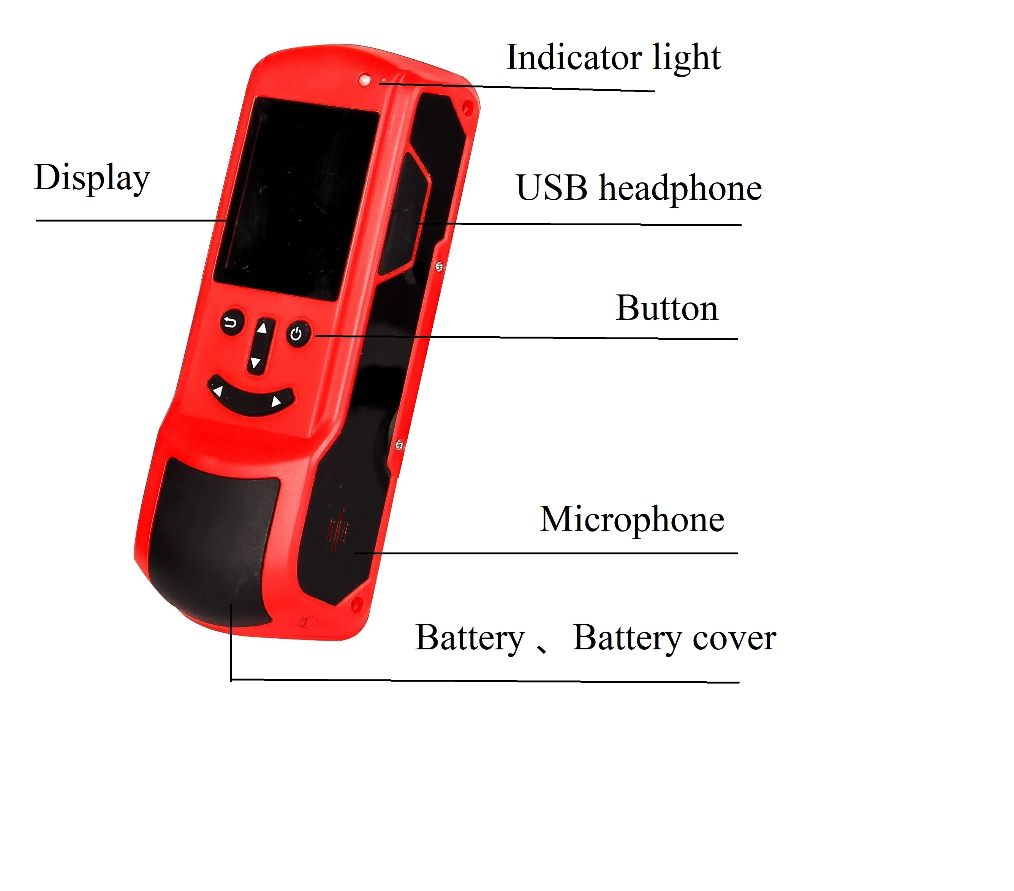
b) Front
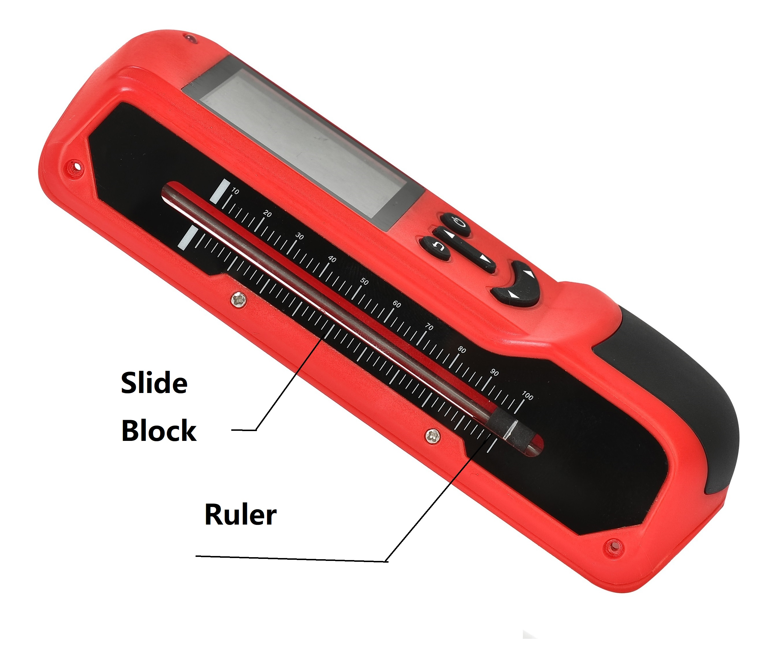
c)Right Side
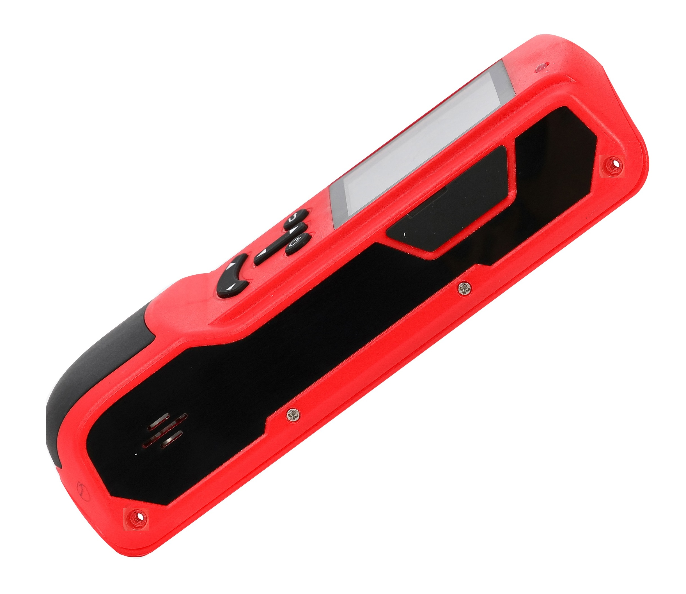
d) Left Side
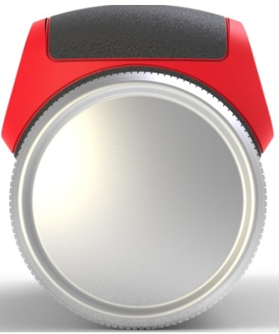
e) Back Side
1. Key button：
Button | Specification Details
【】 | Turn on & Off ; Confirm setting key
【▲】 | Move upward or change page ; shift number or alpha
【▼】 | Move downward or change page; shift number or alpha
【▶】 | Move Right
【◀】 | Move Left
【】 | Return; Cancel
2. Display
Show specification and relative data
3．Indicate light
Indicate USB & Charging State
When light is red, it is in charging; when turn green, charging is finished.
4．Micro USB Port
USD port is at right side for data transfer and charger.
5．Headphone Jack
Connect to headphone.
6．Battery Cover
Pull off to take off cover to remove battery.

3 Operation Process

3.1 Data collection process.
Next, we will show menu function, hammer state and test data and result.

3.1.1 Main menu.
Press 【】 to turn on or off the hammer and go to main menu: Fig.3.1（a、b）.
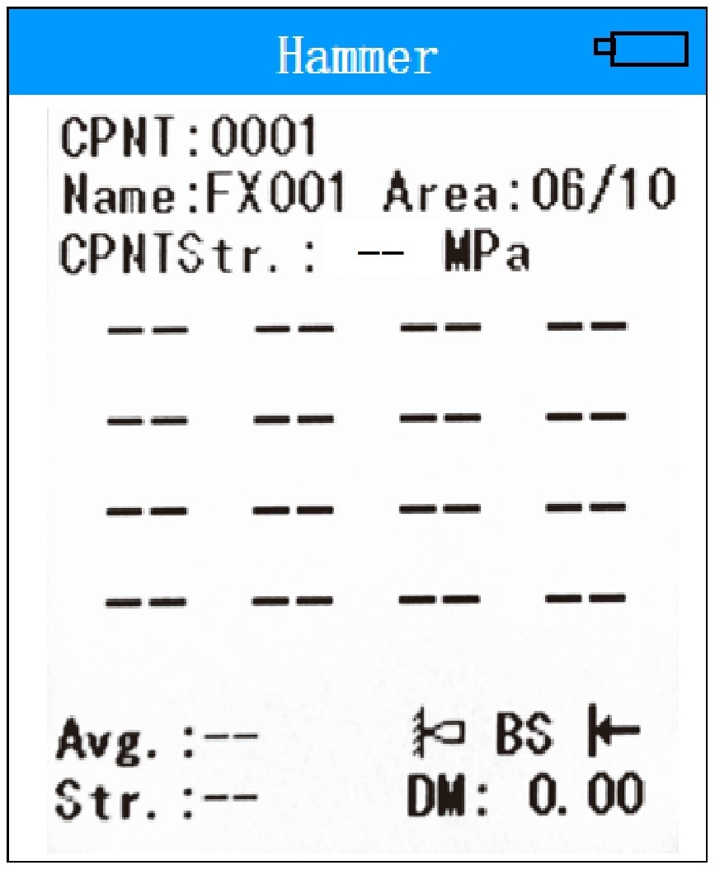
a. Testing Menu
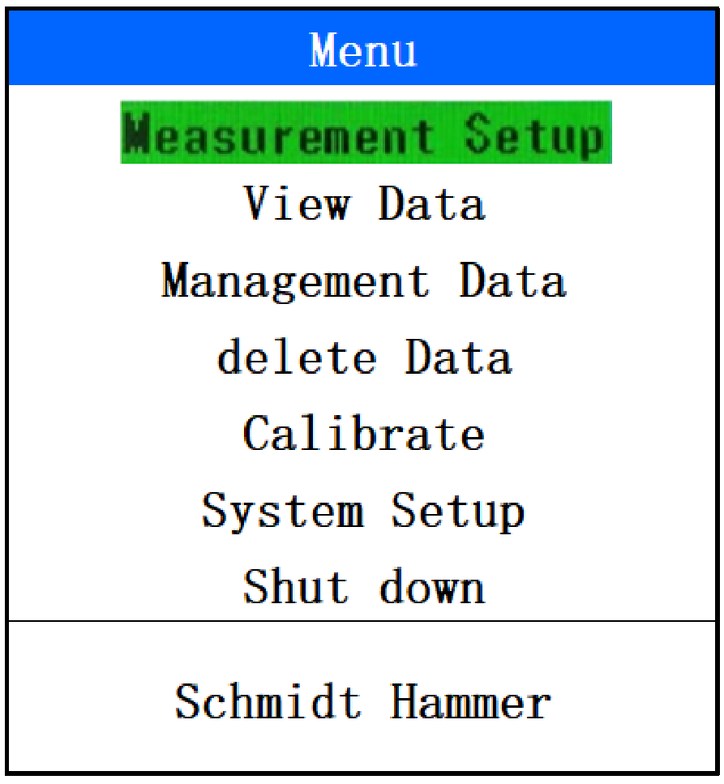
b. Main Menu
Fig3.1 Testing and Main Menu

3.1.2 Testing menu
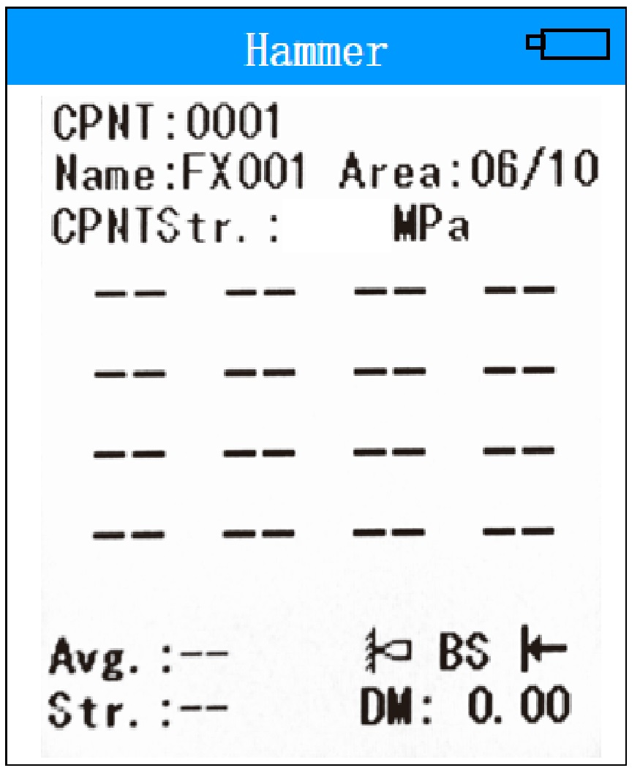
Fig 3.2 Testing Menu
When turn on, it directly come into testing menu. It can do rebound testing without any adjustment; if need to adjust parameter or concrete carbonation value, press 【▶】to adjust value. Then press【】to confirm or 【】to cancel or delete the last rebound value.

3.1.3 Choose menu or setup
Press 【▲】、【▼】to choose menu and 【▶】 or【◀】to adjust chose menu data. Next 【】 confirm operation; while 【】cancel or return to main menu. Fig. 3.3.
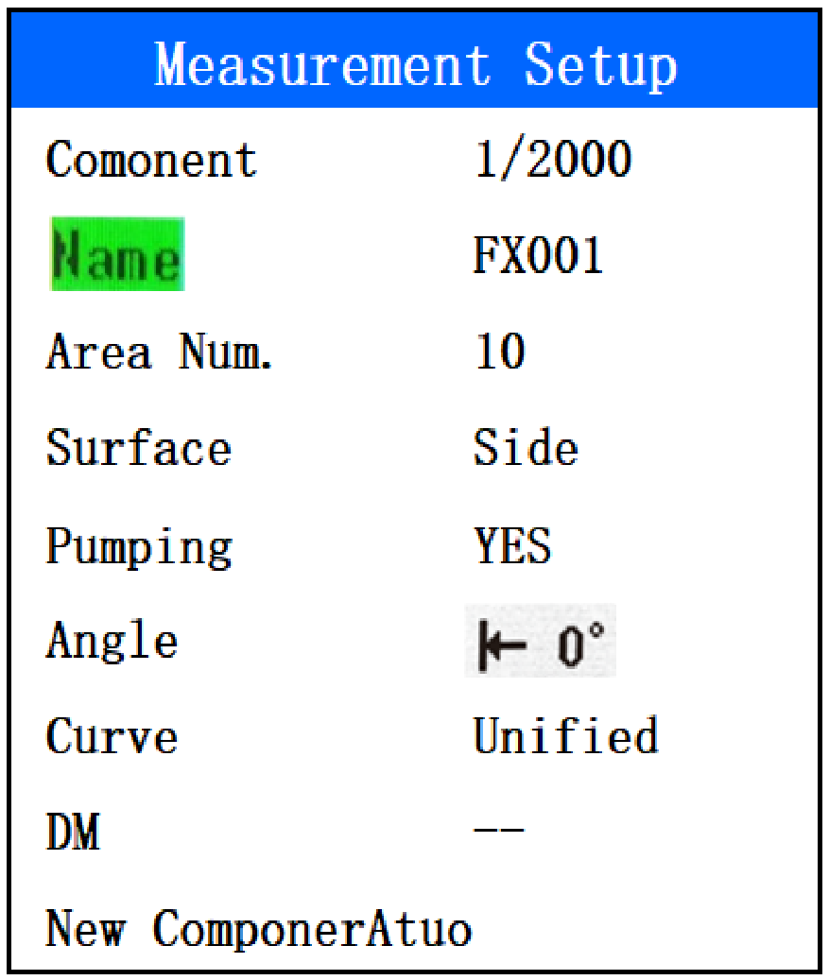
Fig 3.3 Parameter set

3.2 Main Function Introduction.

3.2.1 Schmidt Hammer (Rebound Value Testing)
In this menu it automatically record rebound value, DM (Carbonation depth ) input, and component strength calculate. As fig. 3.4.
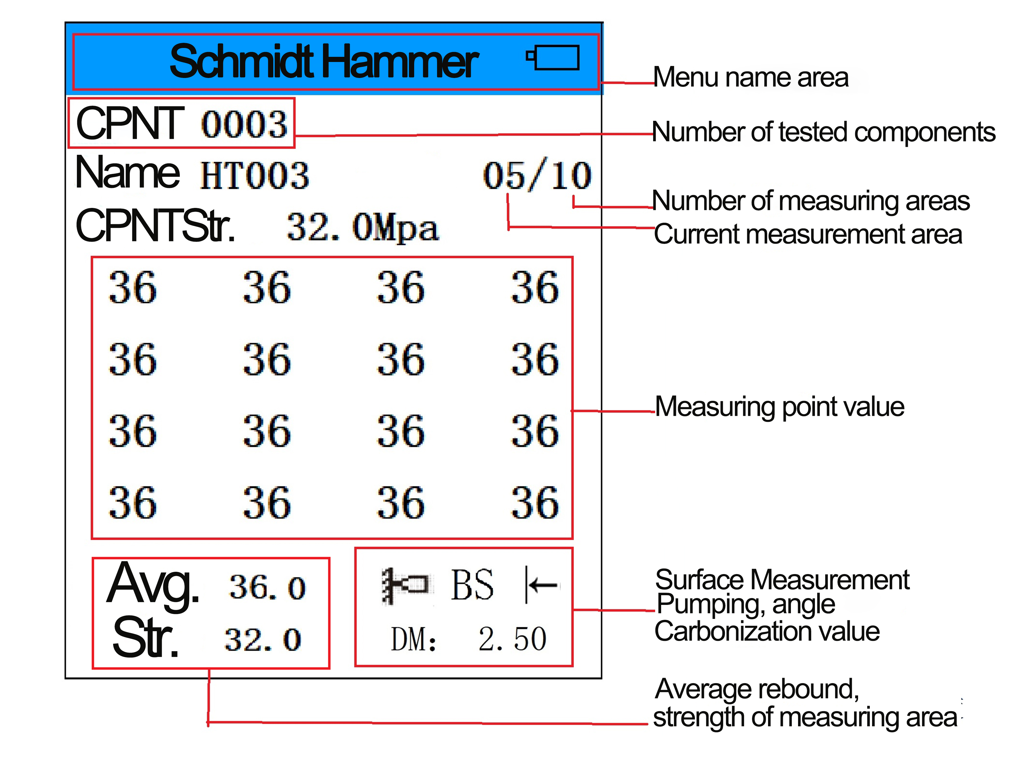
Fig 3.4 Rebound Value Testing Interface
When turn on Digital Rebound hammer, it go into Fig. 3.4
- Main Menu area.
- Component Number: Already finished testing number.
- Testing area total number.
- Present area number
- Rebound value: total 16 pieces
- Testing surface, Angle and DM value.
- Average Rebound Value & Strength value.
During Rebound testing, it displays each point value and calculate average value at same time. When present area testing finished, it automatic come into next testing area and number adding one; The component number is same.
When Rebound value is wrong, press【】to cancel the last value. Fig. 3.5
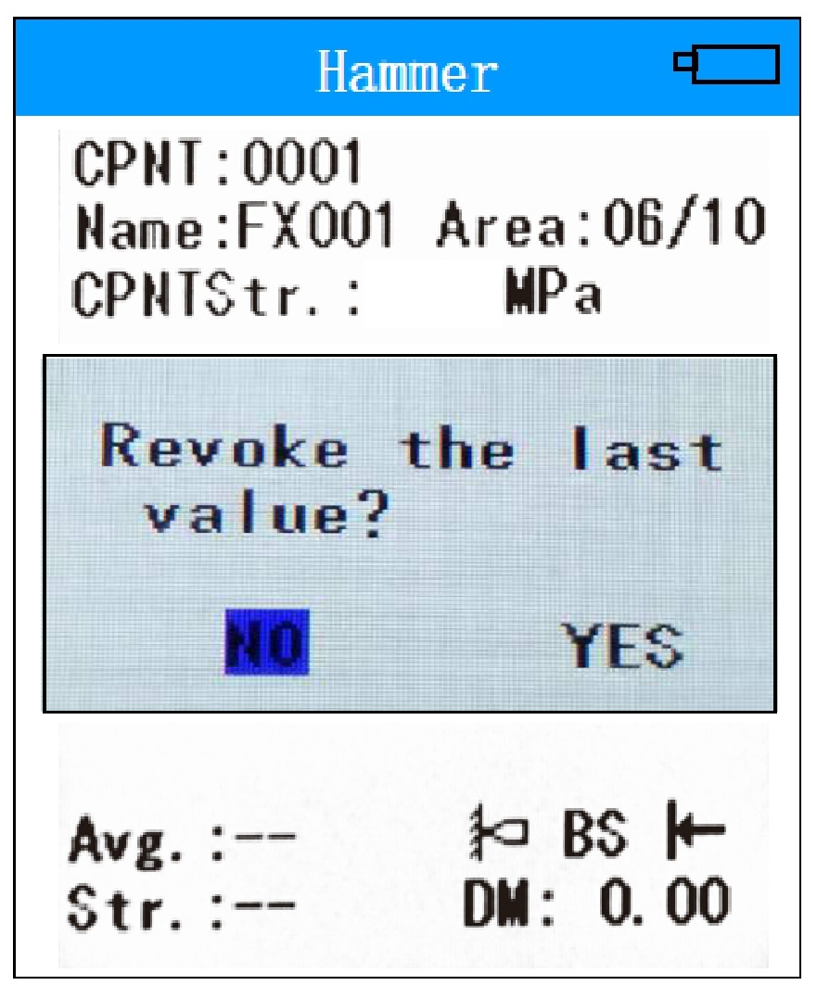
Fig3.5 Cancel last reboud value
If the present component area testing is not finished and want to go the next component, please press【◀】to build a new one. Fig. 3.6.
During tesing, it can use【▶】&【】shift testing menu to parameter setting menu. After change parameter and continuously rebound testing.
If have voice function, it can read value at same time.
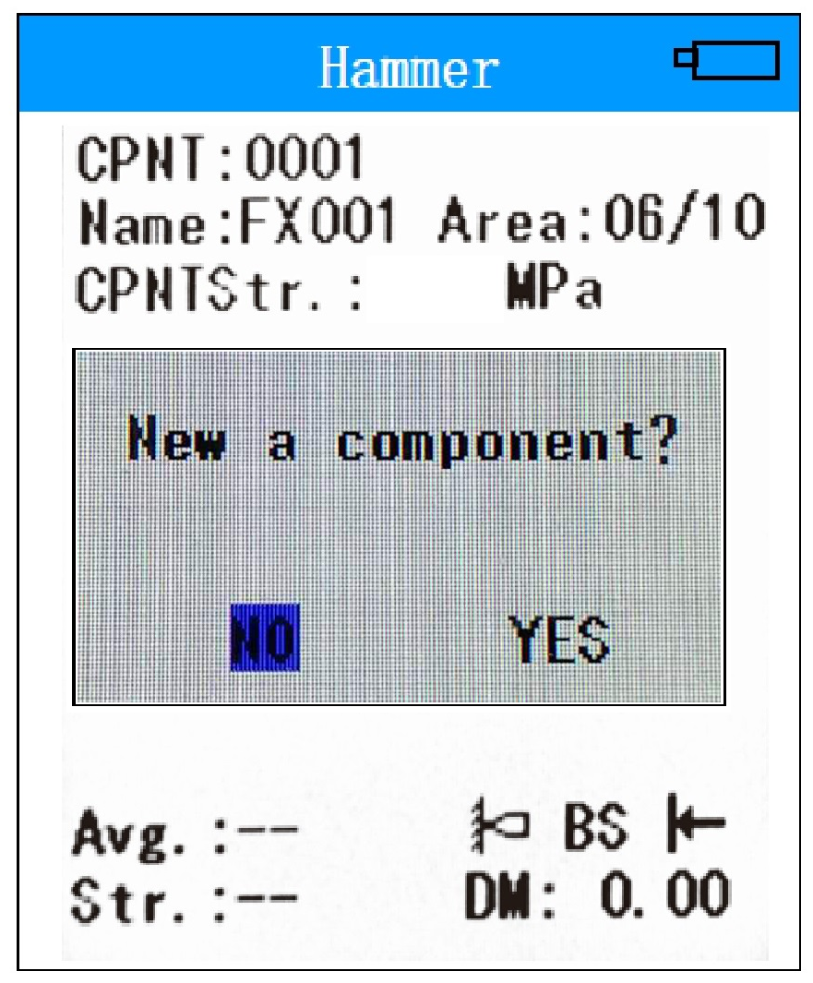
Fig 3.6 New Component Name Interface
Operation button function as below:
【▲】 ：Move course or Upward to browser data
【▼】 ：Move Course or Downward to browser data.
【◀】 ：Move Course; build a new component
【▶】 ：Direct to testing menu; support fast shift between testing and parameter menu; move course
【】 ：To main menu; confirm key.
【】 ：Cancel present area last data; support fast shift between testing and parameter menu
Note：
When present component testing is not finished, it can continuously test after turn off and turn on again; When build a new component, it only can browser data. But cannot continuously testing again.

3.2.2 Measurement Setup
The measurement setting means that the measurement parameter setting mainly includes the realization of functions such as component name, number of test areas, test surface, test angle, and carbonization value; Fig. 3.7.
Fig 3.7 Measurement Setup
Press【▶】to set component name, the value is with blue color back. Through【▼】、【▲】change and choose relative number or alpha. After setup is over, use【】confirm name; Then same way for area number setup. Use【▶】change testing surface: Surface, Side or Bottom. Next same way for Pumping, Angle and Curve. Press 【▶】nput three time DM value and use【】to confirm and return to upgrade menu. Use【】return to main menu and again【】shift to testing menu.
Component: Present component number /Total component number .
Name: Component name ; Area Number ; Surface: Surface, Side & Bottom; Pumping: Yes/ No. ; Curve: Unified ; DM value. ; New Component: Build new one mode: Auto or Manual.
（1）Name: Component name.
Component name have 2 alpha and 3 number, as A、B、C、D、E、F、G、H、I、J、K、L、M、N、O、P、Q、R、S、T、U、V、W、X、Y、Z、1、2、3、4、5、6、7、8、9、0； HT001 as default and after confirmed, it add one number. It also can adjust by user.
（2）Area Number
Setup the rebound testing area range from 01~20，10 as default.
（3）Surface
Setup rebound testing concrete surface and have 3 type: Surface, Side & Bottom.
（4）Pumping
It can choose: Yes/ No. Some place only have one pump curve, software will close choose function.
（5）Angle
There are 9 mode: Up90º、Up60º、Up45º、Up30º、level 0º、Down 90º、Down 60º、Down 45º、Down 30º
（5）Curve
It have international curve inside that can be used.
（6）DM( Carbonation Depth value)
Please follow your local standard to get relative Value.
DM value is 0 as default. Please choose DM and press【▶】to setup DM value; Fig. 3.8.
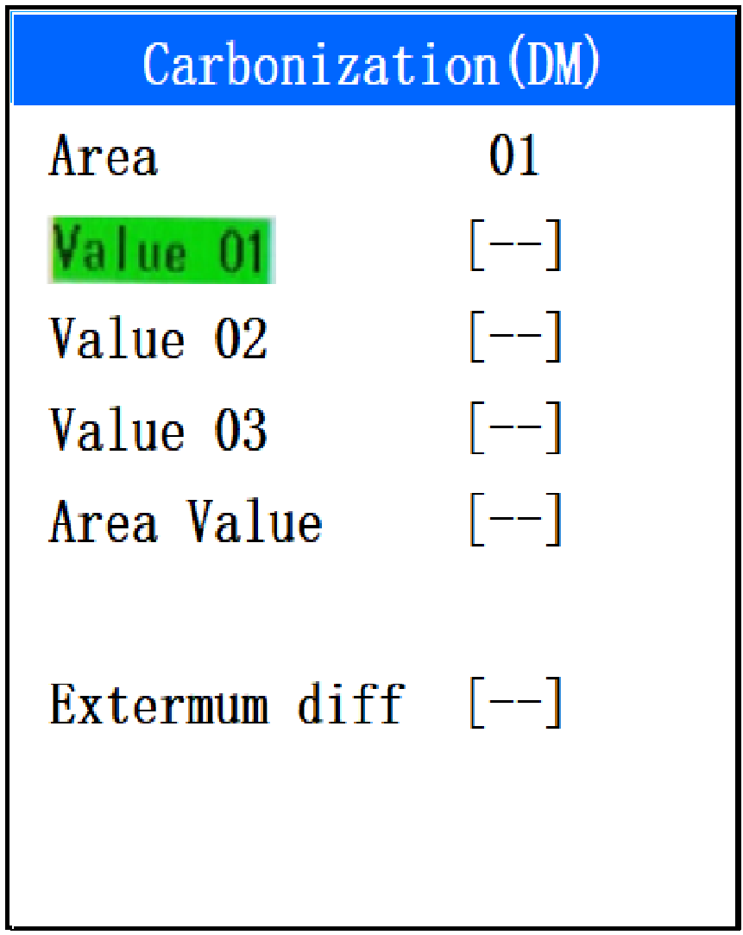
Fig 3.8 DM
（7）New Component
Build new components. Normally it set Auto as default and after one component testing finished, it adds one automatically. It also can choose Manual by user.

3.2.3 View Data
View component data list and survey area data list; mainly include component number, average intensity, minimum intensity, average carbonization, standard deviation, estimated intensity, and measured point values; Fig. 3.9、Fig. 10.
In Menu Press【▼】to choose View Data and use【】to view components data. Use【▶】、【◀】to change page to browse component list data；Again use 【】browser testing area data of relative components. Press【】return.
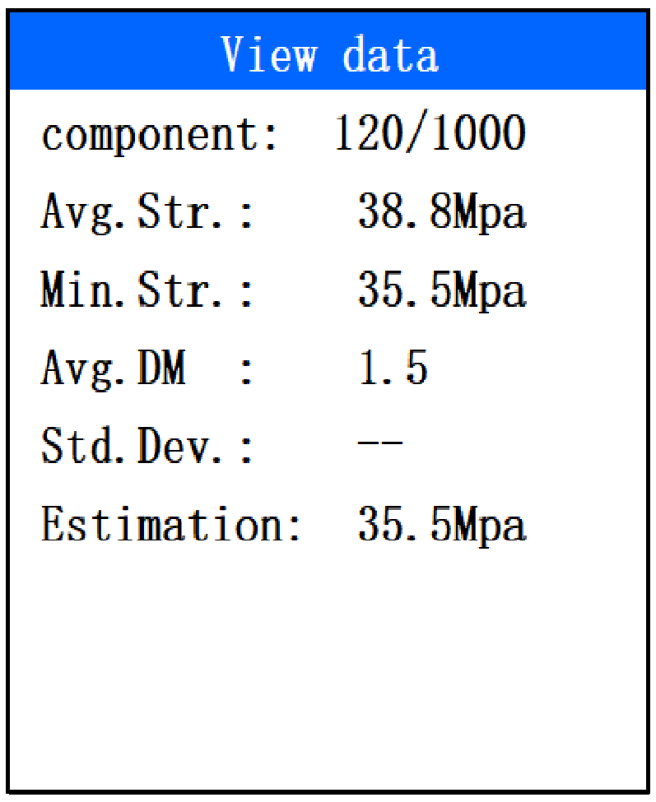
Fig 3.9 Component Data Viewing
Fig 3.10 Survey area data viewing

3.2.4 Management Data
Bluetooth data printing, wireless upload, custom export data, etc .; select the start and end range of the print component; and automatically connect the Bluetooth printer with a Bluetooth icon to show whether the success is continuous; Fig. 11.
In Menu press【▼】Choose Management Data，use【】to data management surface. Press【▼】、【▲】、【▶】、【◀】to choose relative items；Use【】to confirm; while【】return.
- Note：
(1) This product supports users to select the starting component and ending component number according to the actual situation, and execute this range separately for printing, uploading, and custom exporting, and then perform corresponding operations.
(2) Bluetooth printer is optional, if necessary, please contact our sales department to purchase;
(3) Please turn on the power of the Bluetooth printer before printing. If there are multiple Bluetooth printers, only one of them is allowed to be turned on. The digital rebound meter will automatically identify and bind the printer. After successful binding, there is Bluetooth in the status bar. The icon appears, and the printer's blue light is always on after the connection is normal.
(4) When replacing multiple printers, please turn off the printer first, select resetting the printer, and then turn on the printer to print.
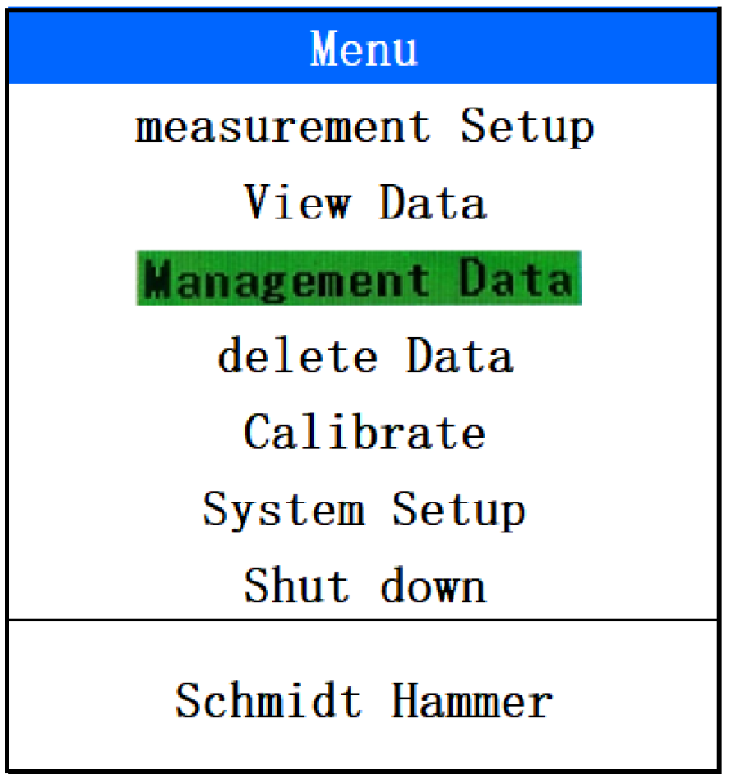
Fig 3.11 Management Data

3.2.5 Delete
Delete saved data; ; Fig. 12(a/b).
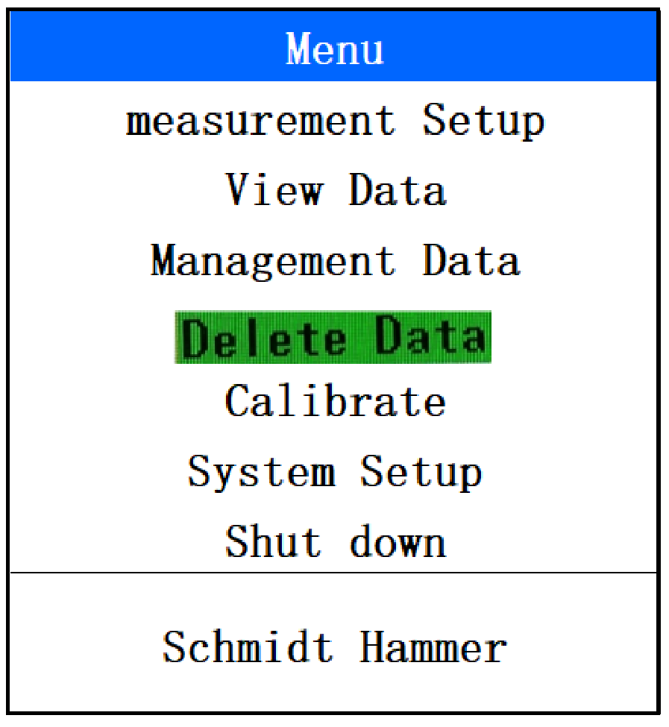
(a)
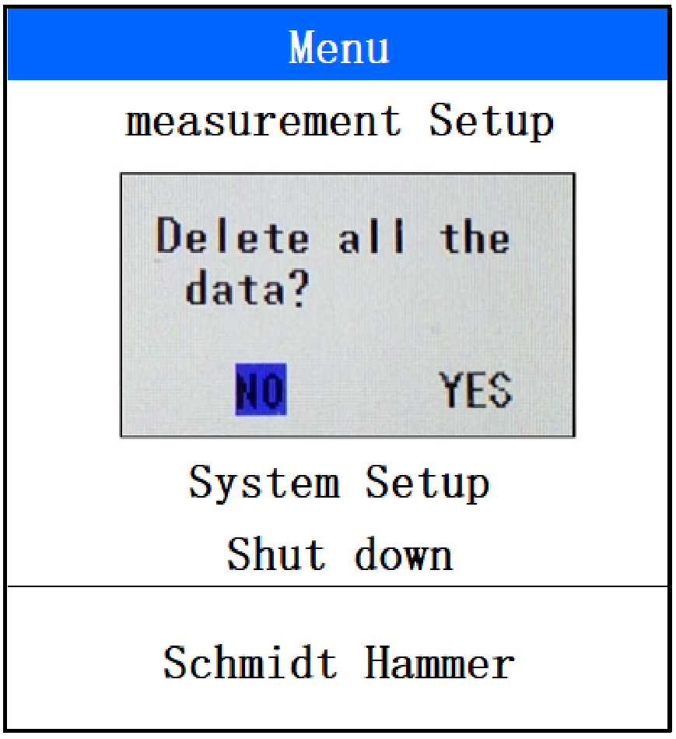
Fig 3.12 Delete Data (b)
In Menu press【▼】Choose Delete Data，Press【】give a dialog whether delete; Use【】Return.
- Note：
Please confirm all data already transfer to pc before delete.
During deleting data, it can not cancel.

3.2.6 Calibrate
Mainly for rebound hammer calibration by Steel Anvil. Through hammer rebound 3 time turn 90º and total 4 group 12 times. The Average value must be 80±2. The average value of 4 groups is calibration value of this time. Fig.3.13(a/b).
During calibration, it will record the value and adjudge calibration value automatically then show result. It also can cancel, clear and save calibration value.
In Menu press【▼】Choose Calibrate and use【】to calibrate surface. Next through【▶】、【◀】to cancel, clear and save. Use【】to return.

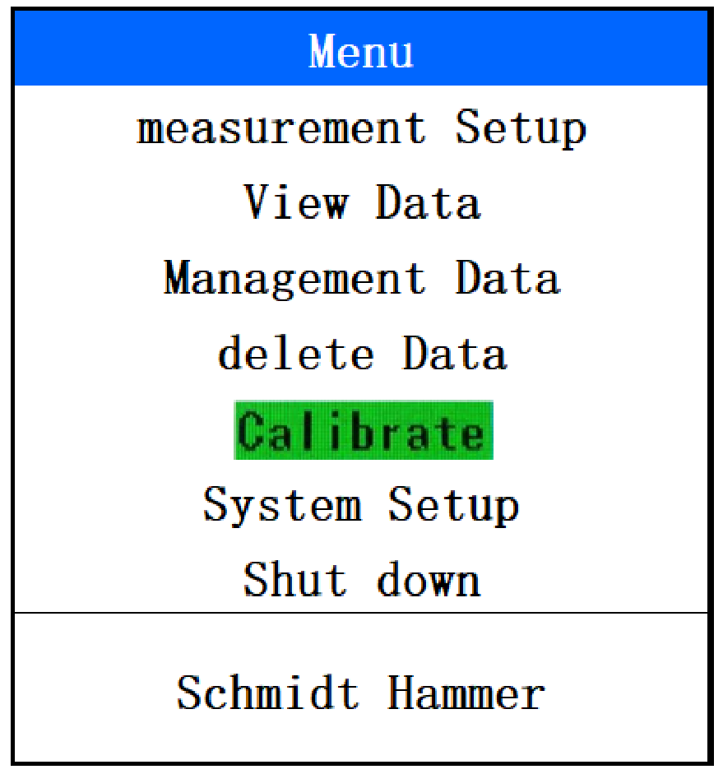
（a）
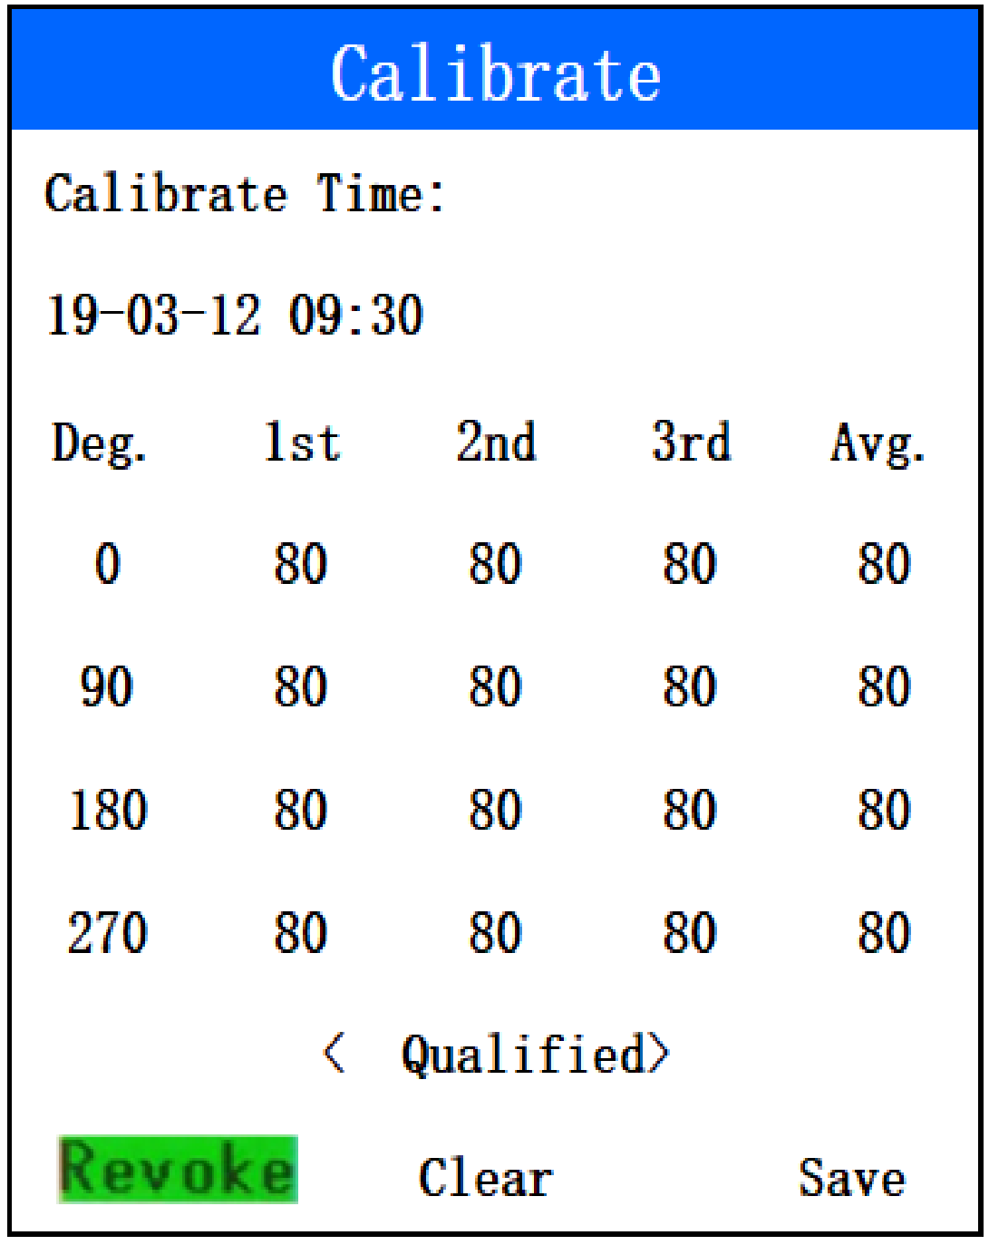
(b)
Fig 3.13 Calibrate

3.2.7 System Setup
The system setting menu interface mainly enables users to adjust the system configuration parameter information, including voice switch, automatic shutdown time, year, month, day, rebound value calibration, range upper and lower limits, language switching, and information about the machine, as shown in Figure 3.14 Shown(a/b).
（1）Voice
It can give voice during testing. It suggest turn off this function to avoid battery consuming to fast.
（2）Shutdown
Automatic turn off without operation long time: Total 6 mode: 5min、10min、15min、30min、60min、90min. 。
（3）Date
Manual adjust the date.
（4）Time
Manual adjust the time.
（5）Correction
Mainly use for small adjustment when the mechanical hammer needle is different from digital value. To keep all value together.

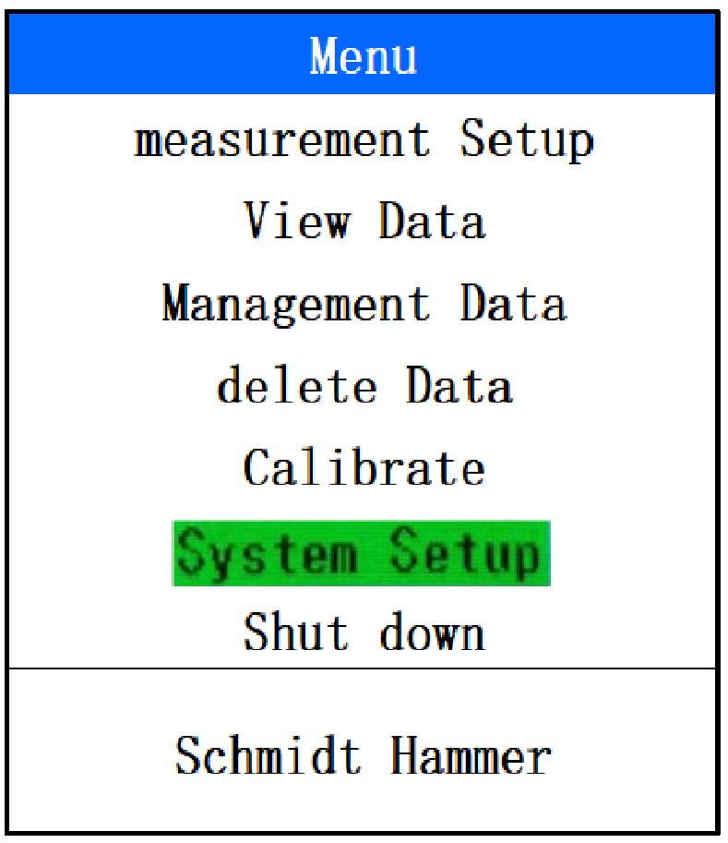
(a)
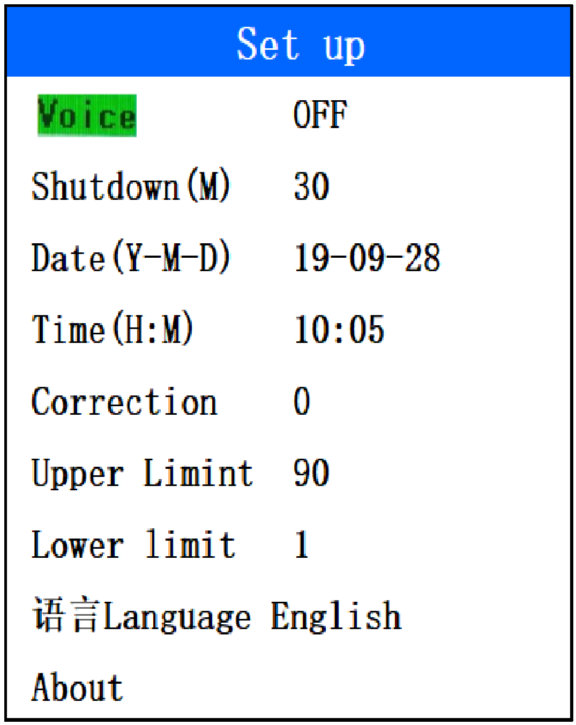
(b)
Fig 3.14 System Set up
（6）Upper/Lower limit
Limit value for rebound value from: 1-99；When rebound on rock or steel in concrete, it will result abnormal value. Please reset back to normal range and cancel to retesting again.

3.2.8 Shut down
It will show battery state on time. When the batter capacity is lower, the battery indicate will change to red frame and yellow color disappear. If for this state, we suggest recharge battery. Fig 3.15 (a/b).
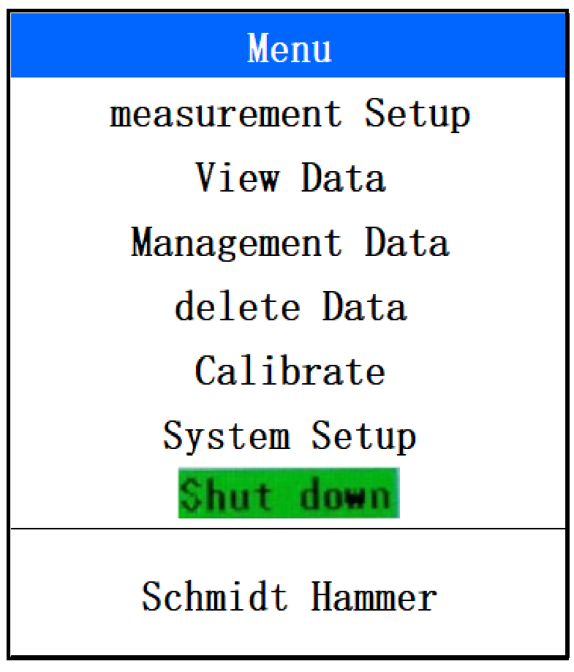
(a)
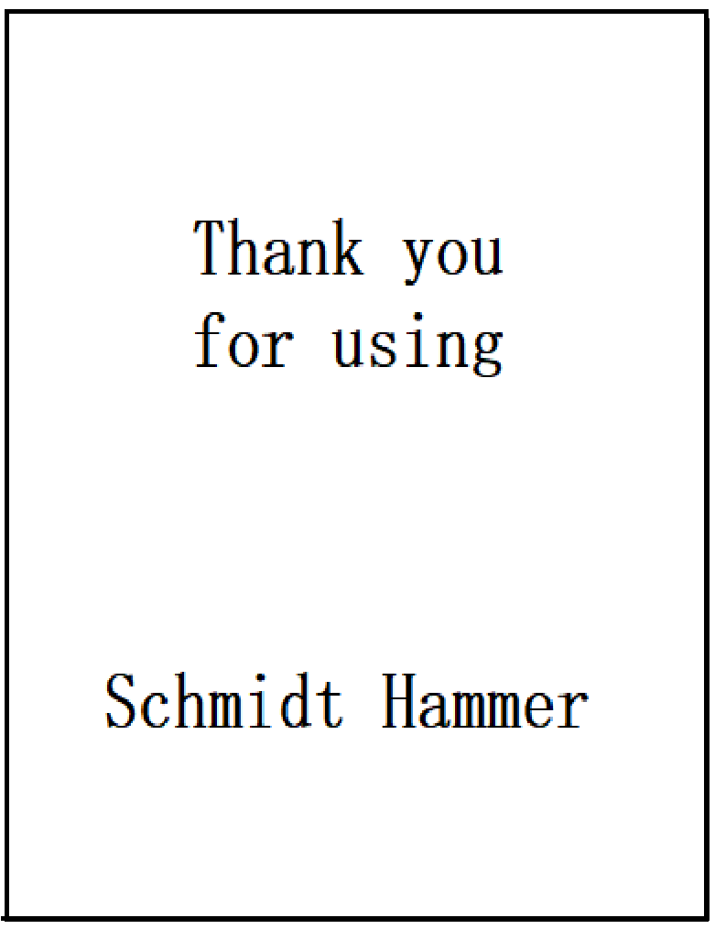
Fig 3.15 Shut down (b)

4 Fast Testing Operation

4.1 Prepare before testing

4.1.1 Field Prepare
Please use grinding wheel to smooth relative components testing area.

4.1.2 Turn on
Long time press 【】, it can turn on or off. When turn on , it will come into testing menu after 3 seconds, Fig 4.1 (a/b).
a. Testing Menu
b. Main Menu
Fig 4.1 Testing Menu and Main Menu

4.2 Rebound testing & Parameter Setup

4.2.1 Rebound Testing

Fig 4.2 Testing Menu
When it turns on can directly go testing menu. If do not need set parameter, it can directly do testing.

4.2.2 Parameter setup.
Press【▶】to set components name and the value back is blue color，Through【▼】、【▲】to choose relative number and alpha. After edit, press 【】to confirm. Next same method to adjust the other parameter.按【】return to main menu, and press【】again to shift to testing menu. Fig. 4.3
Fig. 4.3

4.3 Data Processing.
After testing, please connect pc by USB cable. During data transfer please turn on digital hammer.

Producer Certificate
Product Name： Digital Test Hammer
Product Model Number：
Serial Number:
Inspection Date：

Inspector
Check Member

Package List

Item | Commodity | Unit | Qty | Remark
1 | Host | Set | 1 | /
2 | Charger | Pcs | 1 | /
3 | USB data line | Pcs | 1 | /
4 | User manual | Pcs | 1 | /
5 | Certificate | Pcs | 1 | /
6 | Warranty card | Pcs | 1 | /
7 | Packing list | Pcs | 1 | /
8 | Software CD | Pcs | 1 | /
9 | Package (box)） | Pcs | 1 | /
10 | Grinding wheels and accessories | Set | 1 | /
11 | Battery | Block | 1 | Standard

Product Warranty Card
Thank you very much for using our products, our company will provide you with the best products and after-sale service. The specific warranty content as follows:
1．Offer a one-year warranty service since the date of purchasing the product, and provide life-long software upgrade, technical services and maintenance services.
2. This warranty card (stamp valid) and the formal purchase vouchers (such as invoice, etc.) will be used together as a basis for warranty.
3. During the warranty period, if the failure occurs under normal circumstances, the maintenance fee is exempted after the technical personnel of our company verify it. In excess of warranty period, the cost and maintenance fee will be charged according to the failure condition of the product.
4. Please check the product carefully after receiving it. If you have any problems, please suggest it within 5 days, otherwise it will be deemed acceptable.
5. In the following cases, the company shall provide paid services:
(1) Abnormal operation, installation and maintenance, not in accordance with the operating manual, cause failure.
(2) Disassembling, repairing and refitting by the organizations or personnel that are not authorized by our company.
(3) Damage caused by natural disasters such as earthquakes, etc.
(4) Damage caused by an accident (such as shock, overpressure).

